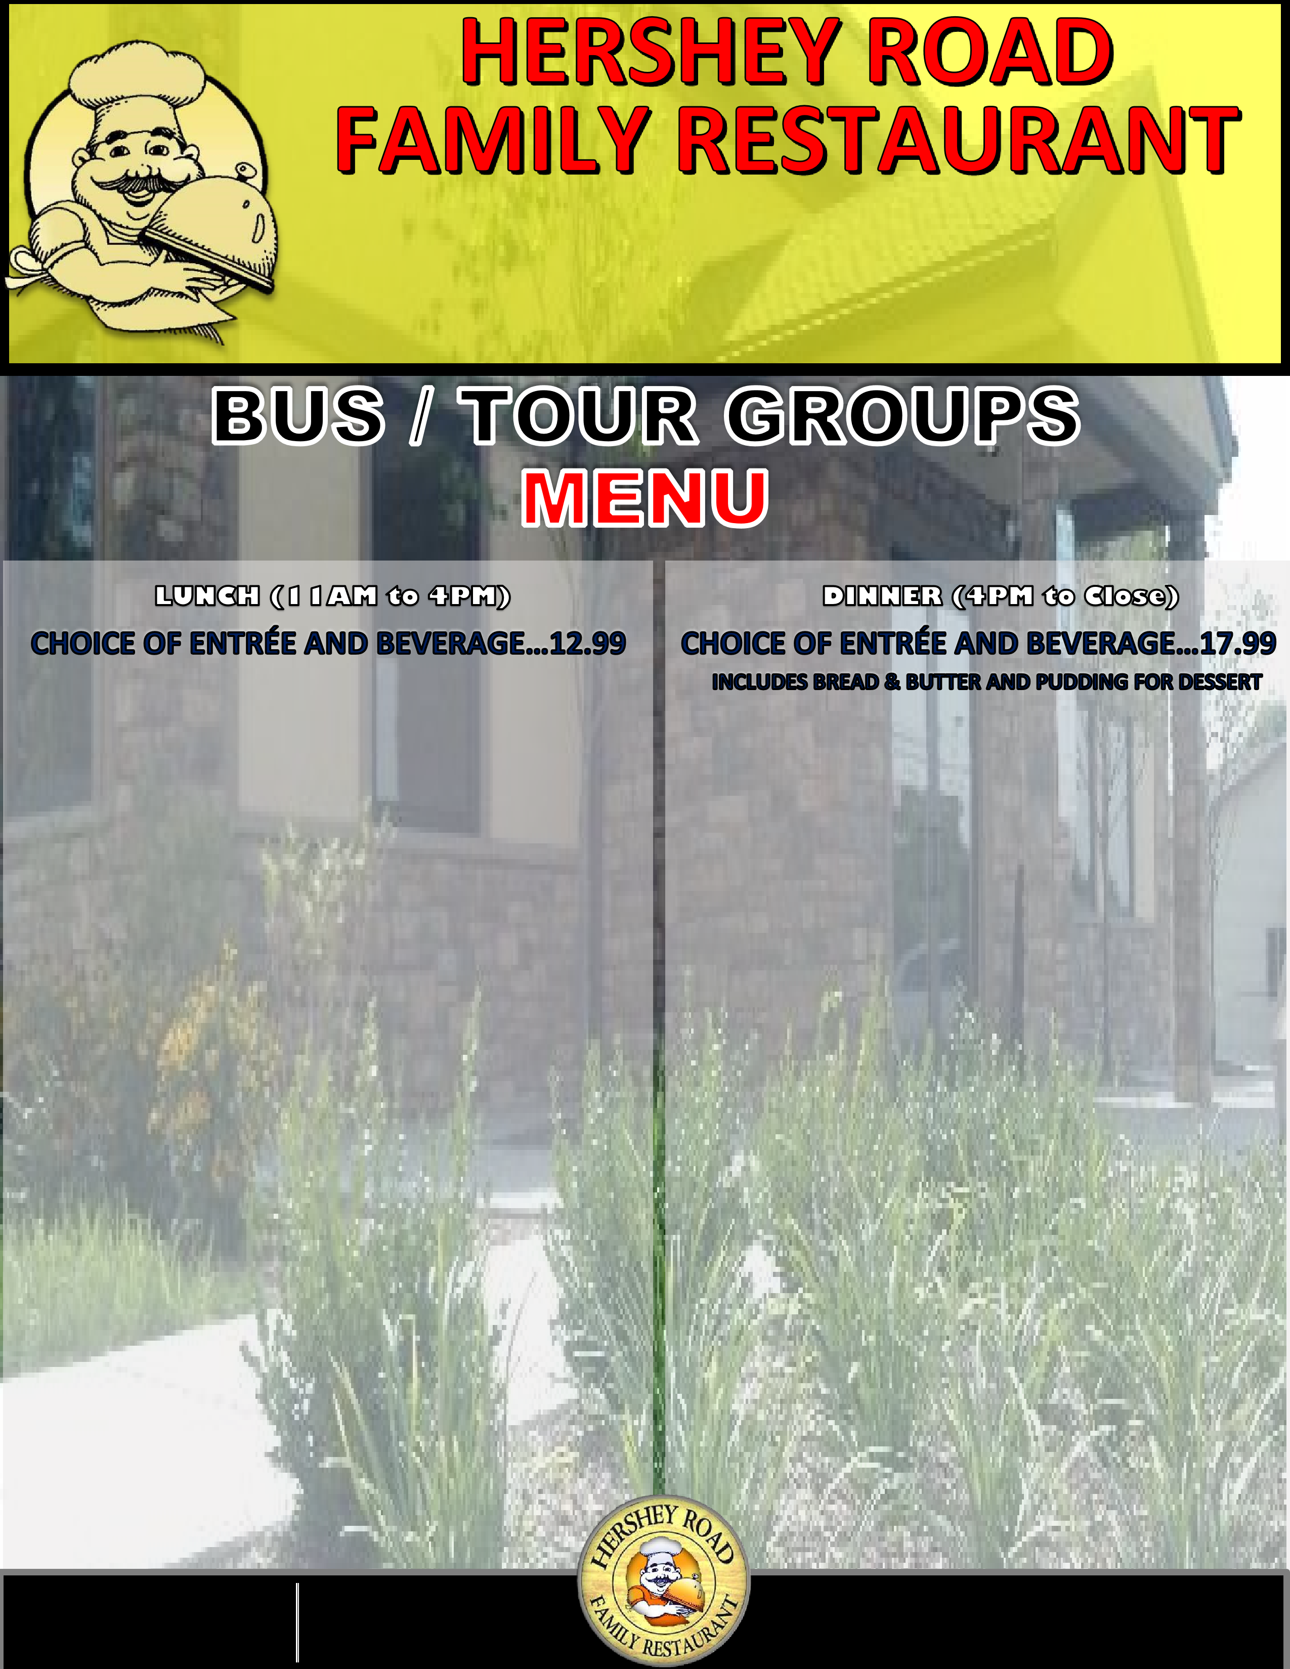

TAX AND GRATUITY INCLUDED

Visit Our Website for More Information www.hersheyrdfamilyrestaurant.com

257 North Hershey Road, Harrisburg, PA 17112 | 1-717-545-2529

**Marinated Chicken Breasts**

Two Grilled Chicken Breasts Served With A Cup Of Soup Or House Salad And Choice Of One Side.

**Roast Turkey Dinner**

Whole Roasted And Sliced Over Filling With

Gravy, Includes A Cup Of Soup Or House Salad And Choice Of One Side.

**Broiled Haddock**

Seasoned With Lemon Butter & White Wine With A Cup Of Soup Or House Salad And Choice Of One Side.

**Roast Beef Dinner**

Whole Roasted Top Round And Sliced Over

Filling With Gravy, Includes A Cup Of Soup Or House Salad And Choice Of One Side.

**Vegetable Primavera**

Tossed With Penne Pasta, Onions, Peppers,

Tomatoes And Mushrooms & Spinach With A Choice Of Alfredo Or Marinara Sauce.

(Gluten Free Pasta Also Available)

**Marinated Grilled Chicken Breast Salad**

With Onions, Tomatoes, Green Peppers & Cucumbers On A Bed Of Salad Mix.

**Philly Wrap**

American Cheese, Fried Onions And Steak Meat Served With French Fries And Coleslaw.

**Reuben**

Thinly Sliced Corn Beef On Thick Grilled Rye Bread

With Melted Swiss Cheese, Sauerkraut And Thousand Island Dressing. Served With French Fries And Coleslaw.

**Kansas City Chicken Sandwich**

Melted Cheddar Cheese, Grilled Chicken Breast,

Bacon And BBQ Sauce. Served With French Fries And Coleslaw.

**Cheddar Burger**

½ Lb. Ground Chuck With Melted Cheddar

Cheese And Bacon, Served With French Fries And Coleslaw.

**Swiss Burger**

½ Lb. Ground Chuck With Melted Swiss Cheese And Mushrooms Served With French Fries And Coleslaw.

**CHOICE OF ENTRÉE AND BEVERAGE…15.99**

**CHOICE OF ENTRÉE AND BEVERAGE…21.99**

**LOCATED JUST 5 MILES FROM HERSHEY PARK AND TANGER OUTLETS.**

**Right off EXIT 77 Rt.81 along Rt.39 Hershey Road, WE CAN**

**ACCOMMODATE GROUPS OF UP TO 50 PEOPLE with convenience of**

**5 MAJOR BRAND HOTELS LOCATED RIGHT NEAR US. Lots of**

**FREE PARKING SPACE AVAILABLE & Bus Drivers get a free Complimentary Meal.**